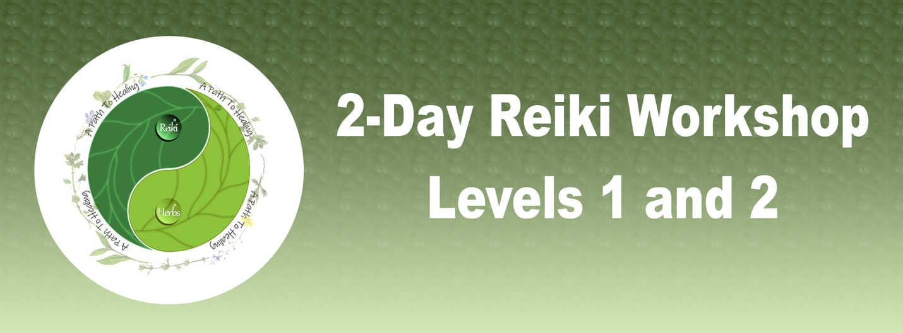

***What is Reiki?***

Reiki is a Japanese technique for stress reduction and relaxation that also promotes healing by channeling life force energy through the practitioner into the client.

* Assists in healing physical and emotional pain
* Assists in breaking old habits and forming new habits
* Improves mental clarity
* Complements Western medical treatment
* More info at: http://www.reiki.org/FAQ/WhatIsReiki.html

***Class contents***

* History of Usui Reiki
* Attunements to Levels 1 and 2
* The Reiki hand positions
* The Level 2 symbols and how to use them
* How to give a complete Reiki treatment to self and others
* How to use Reiki for specific conditions
* How to use Reiki to heal unwanted habits
* How to send distant healing
* Japanese Reiki Techniques
* Class manual

This workshop is a combination of lecture, discussion, and experience. Practice time includes giving and receiving Reiki treatments using various hand positions, practicing self-treatment, scanning others.

**Instructor: Agnes Prescott, Reiki Master/Teacher   
(503) 816-5419 •** [**agnes@apathtohealing.life**](mailto:agnes@apathtohealing.life) **FEE: $350 – DATE: Check Calendar For Next Available Class TIME: 9am-5pm  
Workshop location to be determined**